COM535 Cyber Security Lab

Instructions

- Login and complete lessons at https://www.hacksplaining.com/lessons

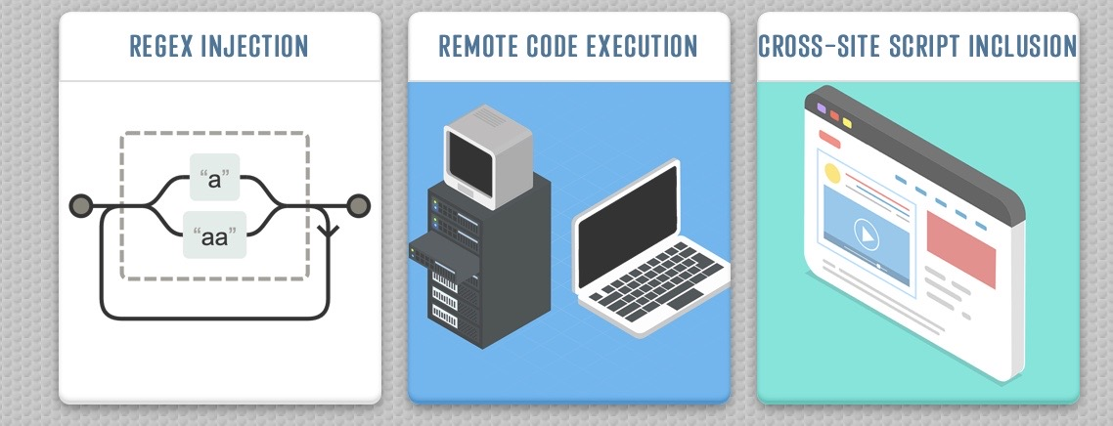

- Complete the vulnerability lessons which are Regex Extension, Remote Code Execution and Cross-Site Script Inclusion.

- Complete the task Splunk – Exploring SPL at:

Splunk – Exploring SPL
https://tryhackme.com/room/splunkexploringspl

Walkthrough Video: https://www.youtube.com/watch?v=Tig5GLzHK08

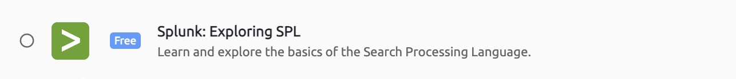

- Complete the task: Intro to logs at:

Intro to logs
https://tryhackme.com/r/room/introtologs

Walkthrough Video: https://youtu.be/ArtVz8ykxTA?si=-NR6f9ZtmriINVeN&t=184

